TIPS FOR TTG’S 11 OCTOBER WTM PREVIEW FEATURE

Deadline for submissions: FRIDAY 10 SEPTEMBER.
We cannot guarantee that exhibitors who submit after this date will be included. Read these instructions then fill in the SUBMISSION FORM document and send it to mbarber@ttgmedia.com.

The Preview feature is your chance to convince the readers of our monthly magazine (ie. travel agents in the UK and Ireland) why they should come to your stand during WTM London.

Reasons for agents to visit your stand could be…
Prizes, celeb appearances, goodies, treats, photo opportunities, training sessions, marketing collateral and product news about destinations they are likely and indeed able to sell.

We’re aware there are on-stand restrictions at WTM London this year, but describe the key themes you’ll be focusing on, and keep it lively!

Bear in mind that agents only attend on Tuesday and Wednesday, so don’t tell us about events on Monday. Also, don’t tell us about press events or closed events which agents could not attend. If agents are welcome, but need to register, please supply an email address so they can contact you.

Your 40-­‐50 word listing will be edited by our team and appear in a grid format like this:

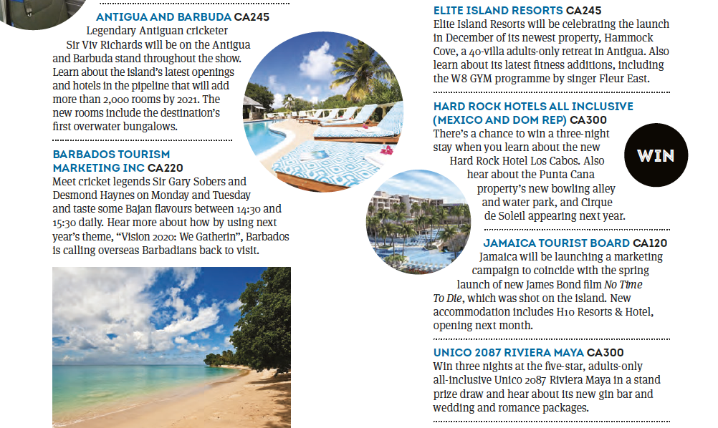

See 2019’s preview feature for examples: https://www.ttgmedia.com/features/wtm-london-2019-a-round-up-of-stands-and-events-19849

Please keep to the 50-­‐word limit in your submission and be pithy and specific. It should look something like this on the submission form:

Exhibitor name and stand number | Elite Island Resorts (CA230)
40-­‐50 word summary | Agents can win a seven-­‐night stay at St James Club Antigua, location for “Judges Homes” filming in The X Factor. The group will also be promoting its new live-­‐booking site, spa-­‐ inclusive suites and a swim workshop with Becky Adlington

If you have high-­‐res photos that might be useful, attach one or two (no more!) to your email. Pix of celebrities, foodie treats, competition prizes and new tourism products are particularly useful. Also pix that can be easily “cut out” to fill in gaps in the grid (eg. smoothie shown to the right).

Exhibitors supporting the WTM Preview feature/WTM Dailies magazines with advertising might be offered an enhanced profile (a Q&A mini interview) in the Preview feature. Please contact head of advertising Anwar Sohawon to enquire about WTM advertising (asohawon@ttgmedia.com).

KEY CONTACTS FOR TTG@WTM:

Madeleine Barber – WTM Dailies editor (both editorial content and sponsored content)
mbarber@ttgmedia.com
07880 170 766

Anwar Sohawon – head of advertising, WTM Dailies
asohawon@ttgmedia.com
07715 365 582

